***The Doane University Center for Computing in the Liberal Arts***

**Consultant Handbook**

**2021-2022**

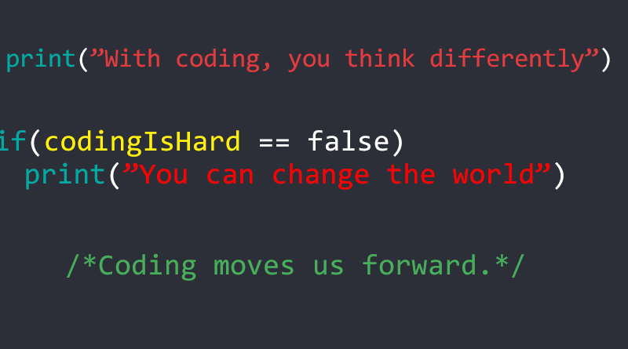

***The Doane University Center for Computing in the Liberal Arts***

**Consultant Handbook**

**Table of Contents**

| **Introduction and Mission Statement** | 3 |
| --- | --- |
| **Letter from the Founders** | 4 |
| **History** | 5 |
| **Fast Facts/Basic Terminology** | 7 |
| **FAQs by consultants** | 9 |
| **Daily Activities** | 12 |
| **Other Responsibilities** | 15 |
| **Do’s and Don’t’s of the CCLA** | 16 |
| **Workplace Guidelines** | 19 |
| **Works Cited** |  |

***The Doane University Center for Computing in the Liberal Arts***

**Consultant Handbook**

Welcome to the CCLA! Hopefully, this will be a guide for you throughout your time employed at the CCLA. As a peer consultant, you will be expected to help people who come into the center with a coding problem to solve. You will aid them in learning the appropriate code to solve the problem, and will be there to help troubleshoot the final code.

The mission of the Doane Center for Computing in the Liberal Arts is to provide students and faculty with a few things. First, we strive to provide computer code training and support to more effectively accomplish their research and personal computing goals. We train knowledgeable peer consultants for all disciplines at any stage in a computer project. Additionally, we strive to provide any information about computers the people need. We are an information center, not IT.

***The Doane University Center for Computing in the Liberal Arts***

**Consultant Handbook**

**Letter from the Founders**

Welcome to the Doane University Center for Computing in the Liberal Arts (CCLA)! The mission of the CCLA is to provide a collaborative and supportive environment for Doane students, faculty, and staff who are interested in incorporating computing into their schoolwork, projects, or research. Our operating analogy is that the CCLA is like a Writing Center, but for computing instead of prose.

Ultimately, the CCLA aims to foster a *culture of computing* at Doane -- all of Doane. Therefore, we must be able to support any academic discipline on campus: STEM disciplines, Business, Art, Social Sciences, Theater, *everyone*. Likewise, we must support a wide range of computing skills, from spreadsheets and word processing through databases and programming and into more advanced technologies such as machine learning or high-performance computing. Our focus is to be available to help any student, faculty, or staff member with any computer related problem solving task. Some may mistake us as an extension of Tiger Tech; however, we are not IT, but instead are an information center.

That is a tall order, but as a CCLA Peer Consultant (PC), you are an integral part of our mission!

The purpose of this handbook is to provide you with general guidance on how to do your job as a CCLA PC, such as record keeping, tracking hours, and so on. The handbook also has guidance on how you should conduct yourself during meetings with CCLA clients. Even if you are a CCLA veteran, please review, in particular, the do's and don'ts of meeting with clients. Always keep in mind that you are not there to do the work for anyone, but rather to help your client do the work themselves.

We sought you out as a CCLA PC because of your interest in computing, your desire to learn, and your willingness to help others learn as well. The CCLA is unique, and you are a large part of our success!

Sincerely,

Mark M. Meysenburg, Ph.D. Catie Welty

Professor of Computing Founding CCLA PC Consultant

CCLA Founder / Director

***The Doane University Center for Computing in the Liberal Arts***

**Consultant Handbook**

**History of the CCLA**

The Doane University Center for Computing in the Liberal Arts (CCLA) provides a collaborative and supportive environment for Doane students, faculty, and staff who are interested in incorporating computing into their schoolwork, projects, or research. The following is a brief history of the CCLA, from its inception to the present.

The CCLA started in the summer of 2018, as part of the National Science Foundation (NSF) funded Digital Imaging and Vision Applications in Science (DIVAS) project, spearheaded by Dr. Tessa Durham Brooks. The DIVAS project aims to teach natural science students how to use programming in their research projects, particularly with computer image processing. The DIVAS project, and other computationally-inspired projects at the University, required someone to provide technical advice and assistance.

Out of this need came the CCLA! Another member of the DIVAS team, Dr. Mark Meysenburg, created the first job description for the new CCLA's director and outlined what the CCLA should be -- a writing center for code. The first director, Adam Erck, started at Doane in the Fall of 2018, and the center's first location was on the second floor of the Lied Science and Mathematics building, in room LI 203. Our founding Peer Consultant (PC) and DIVAS project alumna, Catie Welty, started in the Fall 2018 semester. By January 2019, the CCLA had moved to larger quarters in the Communications Building, room CM 188.

In the Summer of 2019, Dr. Meysenburg received a NSF Cybertraining grant, which included funding to help establish a culture of computing at Doane, and to package the CCLA into a format that could be easily adopted by other universities. A significant portion of the grant funding is set aside for hiring Doane students to serve as CCLA PCs.

The Spring 2020 semester was particularly challenging. Mr. Erck left the university for another career opportunity. After his departure, A.J. Friesen served as interim CCLA director. Then, the COVID-19 pandemic sent us all into an online education mode after spring break. In the 2020-2021 academic year, the CCLA lost its physical home as CM 188 was needed to allow the Academic Success Center to operate in a socially-distanced manner. Ms. Friesen also left the university, leaving the CCLA once again without a director. Throughout these disruptions, the CCLA was able to continue to provide support to the Doane Community through Zoom consultations.

In the Spring 2021 semester, Dr. Meysenburg recruited a new group of students to join the CCLA. These 11 students worked through the summer of 2021, training and honing a wide variety of skills, under the guidance of Catie Welty, who graciously agreed to work through the summer after her graduation from Doane in order to rejuvenate the CCLA.

In the Fall 2021 semester, with Dr. Meysenburg acting as the director, the CCLA resumed in-person meetings with clients, operating out of the Doane Learning Commons.

***The Doane University Center for Computing in the Liberal Arts***

**Consultant Handbook**

**Fast Facts and Basic Terminology**

**Location:**

The CCLA is located currently in the Learning Commons as a Satellite desk. You are encouraged to try to set up the CCLA at a table in the back of the Learning Commons (more about this in the section titled **Opening the CCLA**).

**Hours:**

The CCLA will be open Monday through Friday when the Learning Commons is open. Once the Learning Commons updates their hours, we will update you on when the hours are.

This schedule is somewhat tentative and could change, depending on the needs of the

campus and visitation patterns. If we notice that some times are in especially

high demand and that other times are only slightly used, we may alter our schedule to

utilize our staff budget more efficiently.

The CCLA will **not** be open during breaks and during the summer.

**Contact:**

There are a few ways to get in contact with the CCLA. First, someone can drop in while we are open and in the Learning Commons. Second, someone can email the CCLA at [ccla@doane.edu](mailto:ccla@doane.edu). Third, someone can sign up for a session at <https://calendly.com/ccla/session-with-peer-consultant>.

**Terminology**:

First, your official title is “consultant”, not instructor, teacher, or tutor. The main reason for this title is twofold. First, we want to distinguish between those who work for the CCLA and the tutors from the Academic Success Center. Second, we want to avoid the power dynamic of you knowing everything about the topic. You might not know everything about something, and that’s ok.

Second, those who utilize the CCLA are “collaborators”, not students. Again, this avoids the power dynamic of you knowing everything about the topic. The other reason for this is that the CCLA is for all Doane faculty, staff and students, so the easiest way to include everyone is to refer to people coming in as collaborators.

Third, meetings with collaborators will be referred to as “sessions”. This will allow for distinction between internal meetings and meetings with collaborators. This is also another way to avoid the power dynamic of you knowing everything about the topic.

***The Doane University Center for Computing in the Liberal Arts***

**Consultant Handbook**

**Frequently Asked Questions (by consultants)**

**What do I do if I can’t help a collaborator?**

If you can’t help a collaborator, be honest. Say that you aren’t sure how to assist them, but you will do your best to help them find the answer. If you know another consultant would be able to assist them, you can tell the collaborator when that consultant is working and encourage them to come back or schedule a new session then. Always make note of what the issue was in the session journal, so if we find a lot of people coming in for the same issue, we can re-evaluate training needs.

**What programs should we use during the session?**

During the session, you should use whatever programs and resources you believe will be helpful. You will have access to a list of what resources the CCLA has, and it is recommended that you start with these resources before moving on to Google.

**What is the goal of a consultant?**

A consultant’s goal is to assist the collaborator with fixing any issues and learning how best their computer can help them reach various goals.

**Does my computer need any particular specs to be a CCLA consultant?**

Most of our resources will be on Google Drive, so your computer doesn’t need to fit any specs as long as it can connect to the internet.

**Do I need to create accounts in any software programs aside from the ones we are using in training?**

You will not be required to make accounts in any additional programs for the CCLA. If you find something that may be helpful for other consultants to have access to, let the director know and they will make any final decisions.

**What happens if by the end of a session, the collaborator still does not understand how to go about solving their issue?**

If at the end of a session, if the collaborator does not understand how to solve their issue, they are welcome to set up another session. In addition to that, they will still have access to the resources used in the session to continue trying to solve the issues outside of the session.

**How long should our sessions last?**

Sessions will last for a maximum of 60 minutes. After that, if the issue is not resolved, collaborators should be encouraged to set up another session.

**If someone is late, how long should we wait to move on to the next session?**

There will only be one session scheduled per hour, so this shouldn’t be an issue.

**How often can collaborators visit?**

Collaborators can visit as many times as they want! There is no limit to how many times a collaborator can visit the CCLA.

**What would happen if a consultant got sick?**

If a consultant can’t make a shift, they should let the director know as soon as possible. The director will let them know of the next steps they need to take.

**What would be the best way for a consultant to make a collaborator feel comfortable?**

The best way to make a collaborator feel comfortable is to assure them that you are here and able to help. Allow them to lead the session as much as possible so you don’t misunderstand what they are here for.

**Are sessions confidential? Or can I talk about what happened in the session outside of the CCLA?**

Sessions are not confidential, however, it is best practice to only talk about sessions with other members of the CCLA staff. Some collaborators will feel embarrassed at the fact that they needed to schedule a session, so it is comforting to them if we only discuss what happens in a session with the people who need to know about it.

**What should a consultant do if a collaborator thinks that the consultant will do the work for them?**

The consultant should gently guide the collaborator by asking questions about where they are in the process. If the collaborator continues to think that the consultant will do the work, the consultant should tell the collaborator that they are there to assist, not do.

**Do consultants get breaks?**

Because consultants will only work one to two hours at a time, there are no mandatory breaks. However, since it is coding practice, you are encouraged to take short breaks (5 minutes or less) to clear your mind when you are working on resolving issues. Additionally, you are able to leave the table whenever you need to in order to go to the restroom, get water, etc.

**Will more than one consultant ever help with one collaborator? If a consultant needs help from another consultant how would we go about that?**

Occasionally, you may not have the knowledge needed to assist a collaborator. You can ask another consultant to help you. If a consultant needs help from another consultant, they should ask the other consultant as soon as possible. Two consultants working the same shift can both work with the same collaborator. In addition, a collaborator can leave part of what they are working on with the CCLA in order to ask another consultant to take a look. However, we highly recommend that the collaborator set up another session.

**What if a consultant can’t make a shift?**

If a consultant can’t make a shift, they should let the director know as soon as possible. The director will let them know of the next steps they need to take.

**What if a consultant needs a few days off?**

If a consultant needs a few days, they should email the director and inform them. The director will let them know of the next steps they need to take.

**What resources is a consultant allowed to use during a session?**

A consultant is able to use any resources the CCLA has, as well as Google. We operate under the idea that our consultants aren’t experts in computing, but they strive to find the answers and help collaborators find the answer.

**Will a consultant use their own computer to help or something else?**

Most of the time, a consultant will use their own computer to access CCLA resources and answer questions. Since we are going to be working out of the Learning Commons, a consultant can always use a computer there if they need to.

**What if a collaborator asks a question to a consultant outside of a session?**

If a collaborator asks a consultant a question outside of session, the consultant can answer as long as it will be quick. If the answer will take more than 15 minutes to give, the consultant should ask the collaborator to schedule a session.

**What if a collaborator has a question that is more IT related?**

If a collaborator comes to us with a question that would be best answered by IT, we would let them know that they should go to Tiger Tech. We can show them where it is, and help them explain the issue.

**Would there ever be a case where a consultant would have to turn down a session?**

A consultant can turn down a session if it is a walk in right as their shift ends. Other than that, a consultant should always try to complete a session. A consultant can encourage a collaborator to schedule a session at a time when another consultant is working if the other consultant would be better suited to assisting with the collaborators issue.

***The Doane University Center for Computing in the Liberal Arts***

**Consultant Handbook**

**Daily Activities**

**Opening the CCLA:**

The majority of our set up will be done by the wonderful Learning Commons staff. If you are working a shift as they set up the Learning Commons, feel free to assist them in any way you can.

1. To start your shift, find where we have been set up for the day.
   1. If you are on the first shift of the day or no one is working the hour before you, you will need to find a table.
   2. We generally encourage you to set up at a table in the back of the Learning Commons.
2. We will have a table tent showing that you work for the CCLA. Make sure you set this up in front of you facing the Learning Commons as a whole.
3. Make sure you clock in!
4. Then take an antibacterial wipe and wipe down the table to ensure everyone remains healthy.
5. Next, you should check the CCLA calendar to see if there are any sessions during your shift. If there are, your main focus should be on assisting the collaborator (look at the next sections for details).
6. Even if there are sessions, you should open up the Slack channel and check for messages. This should stay open on your computer for your whole shift.
7. If there aren’t any sessions, check the CCLA email and respond to any that you can, and let the director know of any emails that they need to respond to.
8. Then look and see if there is anything you have been asked to do for this shift.

**Scheduling a Session:**

*Using Calendly*

Calendly is what the current Writing Center uses to schedule sessions. This will be on our website for people to sign up for sessions on, and will connect to the CCLA calendar. All you will have to do as the consultant is check the calendar for any scheduled sessions.

*Using Email*

If a collaborator emails asking to schedule a session, you can add it to the CCLA calendar if they know what time they would like to come in. If they don’t know a time, direct them to the CCLA website so they can sign up for a session using the Calendly link.

*Walk Ins*

Collaborators can always walk into the CCLA without scheduling a session. If a collaborator walks in while you are in a scheduled session and you are unable to assist them at that time, politely ask them to schedule a session or come back at another time. If you are not currently in a session, greet the collaborator and start a session with them!

**Session Workflow:**

See the flowchart on the next page for the general steps to follow for running a session.

Please note: this is just a guideline, not a step by step. Some sessions will look different from this depending on who the collaborator is and what they are coming to the CCLA for. Also remember to not bring up coding yourself; let the collaborator bring it up if that is what they need assistance with.

**Closing the CCLA:**

This only applies to those working the last shift of the day. You should do what you can to assist the Learning Commons staff in closing the Learning Commons once you are done with the CCLA closing tasks.

1. First, make sure that any computers you logged into are logged out of.
2. Then push the chairs in around the table you have been working at.
3. Next, wipe down the table with an antibacterial wipe.
4. Finally, return the table tent to the Learning Commons front desk.

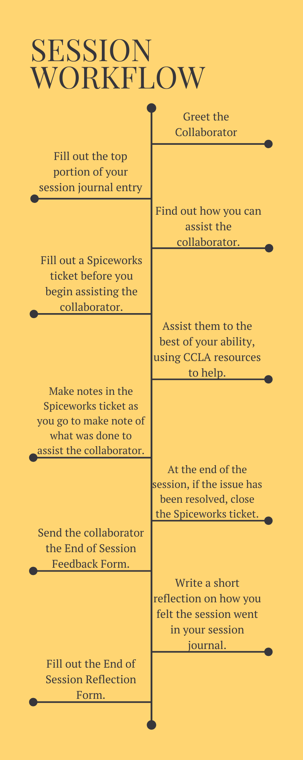

***The Doane University Center for Computing in the Liberal Arts***

**Consultant Handbook**

**Other Responsibilities**

**Class Visits:**

We may occasionally have consultants visit classrooms. These visits can be for a couple purposes. The first is an advertising visit, where the main purpose is to inform the students about what the CCLA is here to do. The second is a teaching visit, where a professor will ask a consultant to visit their class and go through a resource with them. These will be set up by the director, and the director will ask who is available to attend these classroom visits.

**Meetings:**

We may also occasionally have staff meetings to check in with everyone and provide extra training. You will be expected to attend these. We understand that everyone has different schedules, and will try to accommodate everyone when choosing a time. However, with so many consultants working, it will not be possible to meet at a time that is perfectly convenient for everyone. We ask that you be flexible with your schedule to accommodate these meetings.

**Session Journal:**

There will be a Google Doc that everyone can access that will function as a collective Session Journal. You will be expected to fill out a general heading for each entry and one to two sentences of reflection for each session you have. If you fill out the last template on the page, you are expected to create the next empty page of templates by copying and pasting the blank templates onto a new page.

***The Doane University Center for Computing in the Liberal Arts***

**Consultant Handbook**

**Do’s and Don’t’s of the CCLA**

It is not possible to predict exactly what will happen whenever you sit down to work with

a collaborator in the CCLA; nNor is it possible to give you a simple list of instructions

for every eventuality. Experience, however, tells us that we will face our share of challenges and difficult situations, many of which are fairly common. Therefore, here are several important session “do’s” and “don’t’s” that may help us prevent the worst of the worst (Note: many of these are for sessions with a student collaborator, as that is the most common collaboration session you will encounter).

| **DO** | **DON’T** |
| --- | --- |
| **Do** read this handbook and refer to it often. | **Don’**t criticize a professor, ever! This  could take many forms. Perhaps you  disapprove of a professor’s comments or  lack thereof. You might not enjoy the  professor’s lecture habits. Maybe you  disagree with or question a professor’s  standards. Keep such things to yourself.  In the CCLA, every professor is  well qualified, means well, cares about  student learning, and works hard to achieve  it. |
| **Do** treat everyone associated with the  CCLA and everyone who visits  with respect, as well as the Learning Commons staff that are graciously allowing us to use their space. | **Don’t** criticize an assignment. You  certainly may want to, especially if you’ve  taken the same course and struggled with  the same assignment. But keep this to  yourself as well. Collaborators, especially if they are a student, will often vent  about an assignment to avoid facing the  hard work required for success. Let them  vent, to a point, but don’t join in. It’s  counter-productive. Your job, ultimately,  is not to affirm and cement their frustration but to help them through it, to help them understand the professor’s instructions and see the value in the work. Indeed, tell them that you understand their frustration, having felt it yourself, but that the assignment has a purpose, and part of the purpose is initial frustration, which is a sign that learning is taking place. You might also tell them that everyone feels frustrated at the start of a new project, especially programmers. It’s normal to the process. |
| **Do** take pride in your work here and  consider your position a privilege, not a  right. | **Don’t** second-guess or attempt to circumvent a professor. A professor may  instruct a collaborator differently than you like or make demands with which you  disagree. That is the professor’s  prerogative, and it is your job to help the  collaborator satisfy the professor’s wishes, not yours. |
| **Do** make the director aware of any behavior or comments, suggestive or otherwise, that make you feel uncomfortable in any way. | **Don’t** tell a collaborator what grade you think their paper should get. The last thing you want to do is assume that kind of responsibility. |
| **Do** take verbal threats directed at you or at the CCLA seriously and report  them to the director immediately. | **Don’t** criticize Doane University or the Doane University administration when you are working with a collaborator. The CCLA and your job, after all, are dependent on the president, the dean, and others for funding. |
| **Do** take plagiarism seriously. If you  suspect plagiarism during a session, talk  with the collaborator about using and citing sources properly. Also make sure to note your suspicions and recommendations in the session journal. Should the collaborator be accused of plagiarism at a later date, we will want evidence that we called the collaborator’s attention to the issue. | **Don’t** make suggestive or insensitive  comments, or tell jokes of a similar nature.  This almost goes without saying, but it’s  wise to be especially careful. When in  doubt, keep it to yourself. |
| **Do** direct all your comments and  observations toward the collaborator’s work, not the collaborator themselves. | **Don’t** direct character judgments or  indictments toward the collaborators with whom you work. It may be true that the collaborator with whom you’re working is lazy, but don’t say it in so many words. Keep your comments and questions focused on the writing and process of writing. |
| **Do** ask questions whenever anything is  unclear or troubling. | **Don’t** assume that what you say to a collaborator will stay between the two of you. It won’t. So don’t say or do anything that you wouldn’t want to see on a billboard outside the Perry Center, or on the front page of *The Owl*, because it just might. |

***The Doane University Center for Computing in the Liberal Arts***

**Consultant Handbook**

**Workplace Guidelines**

The CCLA adheres to the employment and personnel policies outlined in the *Doane College Student Worker Handbook*. Please review this information carefully, as you will be expected to act in accordance with it. See especially the material related to attendance, appearance, conduct, and payroll. Notice that you must visit the Payroll Office (in Padour Walker) as soon as possible and complete an I-9 form and a W-4 statement, if you haven’t done so previously as a student employee.

In addition, please observe a number of guidelines that will help us maintain a positive yet professional environment:

* Complete the Spiceworks ticket AT THE TIME of the session. Do not attempt to recreate them later. You will surely forget much of what occurred and what was discussed, which means you will have to resort to guessing, neither of which is useful here.
* Dress properly, which means comfortable yet modest attire. You need not wear formal business attire. What you might wear to class is fine, as long as you appear approachable.
* Keep visits by friends and significant others brief and to a minimum.
* Sessions must be conducted in the Learning Commons and during CCLA hours, not other places on campus and certainly not in your dorm room or apartment. If the weather is nice, sit near an open window rather than going outside to the steps or a nearby bench.
* The CCLA is not a dating service.
* It is perfectly acceptable to do homework but only if no one is waiting for help. If you are doing homework and someone arrives for help, stop immediately and attend to their needs.
* Treat our collaborators in a way that makes them feel comfortable and welcome. In general, we should operate under the Golden Rule, and treat our collaborators the way we would like to be treated if we were in their shoes.